
Institute of Management Sciences
Peshawar-Pakistan

DATABASE LAB PROJECT
Project Title: Online Tutoring Management System
Project By: Sidra Noor And Muskan Iqbal
BSSE (GROUP-B)
4th SEMESTER

MILES STONES | VERSION | DATE | REMARKS
ERD, Relational Schema | 1.0 | 26-04-2026

MILESSTONE-1
ERD {Entity-Relationship Diagram}
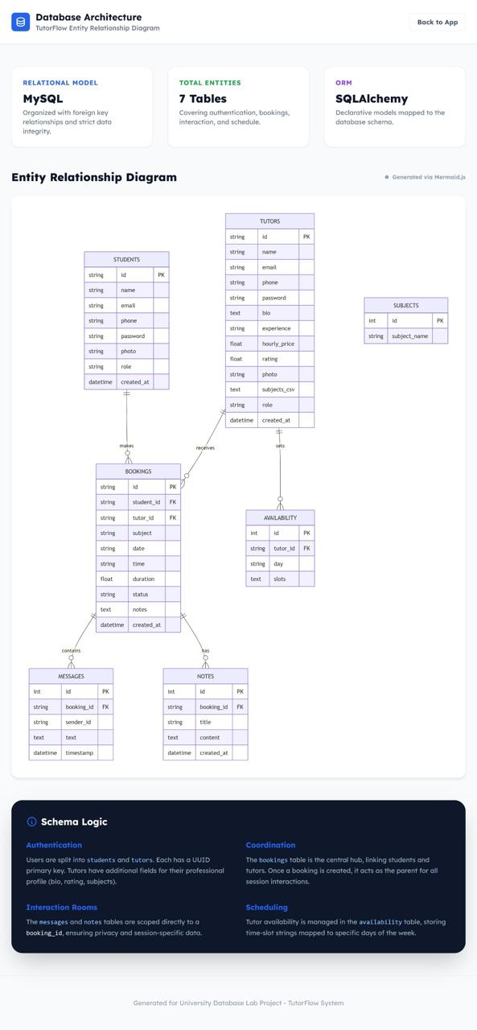

CREATE TABLE students (
id VARCHAR(50) PRIMARY KEY,
name VARCHAR(100),
email VARCHAR(100) UNIQUE,
phone VARCHAR(20),
password VARCHAR(100),
photo VARCHAR(255),
role VARCHAR(20),
created_at TIMESTAMP DEFAULT CURRENT_TIMESTAMP
);

CREATE TABLE tutors (
id VARCHAR(50) PRIMARY KEY,
name VARCHAR(100),
email VARCHAR(100) UNIQUE,
phone VARCHAR(20),
password VARCHAR(100),
bio TEXT,
experience VARCHAR(100),
hourly_price DECIMAL(10,2),
rating DECIMAL(3,2),
photo VARCHAR(255),
subjects_csv TEXT,
role VARCHAR(20),
created_at TIMESTAMP DEFAULT CURRENT_TIMESTAMP
);

CREATE TABLE subjects (
id INT AUTO_INCREMENT PRIMARY KEY,
subject_name VARCHAR(100)
);

CREATE TABLE bookings (
id VARCHAR(50) PRIMARY KEY,
student_id VARCHAR(50),
tutor_id VARCHAR(50),
subject VARCHAR(100),
booking_date DATE,
booking_time TIME,
duration DECIMAL(4,2),
status VARCHAR(50),
notes TEXT,
created_at TIMESTAMP DEFAULT CURRENT_TIMESTAMP,

FOREIGN KEY (student_id) REFERENCES students(id),
FOREIGN KEY (tutor_id) REFERENCES tutors(id)
);

CREATE TABLE availability (
id INT AUTO_INCREMENT PRIMARY KEY,
tutor_id VARCHAR(50),
day VARCHAR(20),
slots TEXT,
FOREIGN KEY (tutor_id) REFERENCES tutors(id)
);

CREATE TABLE messages (
id INT AUTO_INCREMENT PRIMARY KEY,
booking_id VARCHAR(50),
sender_id VARCHAR(50),
message TEXT,
created_at TIMESTAMP DEFAULT CURRENT_TIMESTAMP,
FOREIGN KEY (booking_id) REFERENCES bookings(id)
);

CREATE TABLE notes (
id INT AUTO_INCREMENT PRIMARY KEY,
booking_id VARCHAR(50),
title VARCHAR(100),
content TEXT,
created_at TIMESTAMP DEFAULT CURRENT_TIMESTAMP,
FOREIGN KEY (booking_id) REFERENCES bookings(id)
);

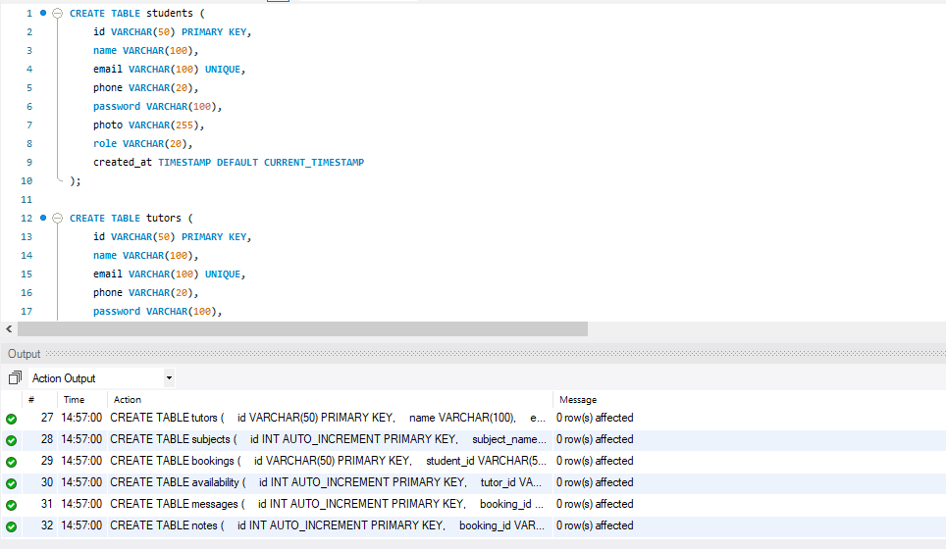

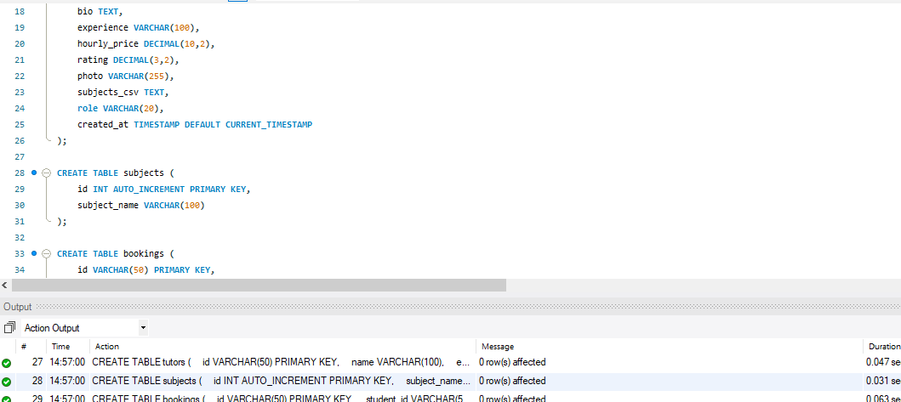

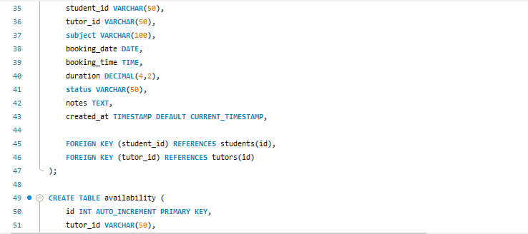

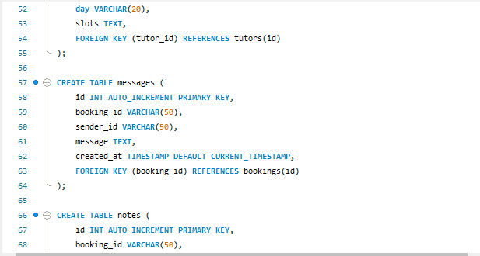

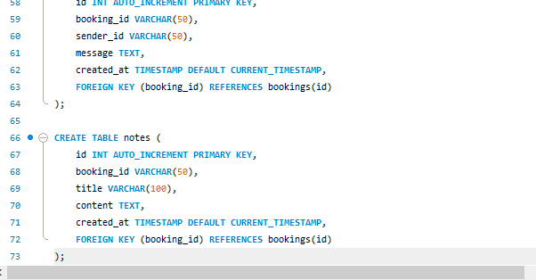
TABLES
